**A Project**

**On**

**ONLINE ADMISSION SYSTEM**



**PROJECT SUPERVISOR**

**Md. Sharif Hossen**

**Lecturer**

**Department of Information and Communication Technology**

**Comilla University , Bangladesh**

**SUBMITTED BY**

**Avik Sarkar**

**Mehedi Hasan**

**Najmun Nahar**

**Md. Mainul Hossain**

**Md. Mohi Uddin**

**Md. Oli Ullah**

**Md. Sadequr Rahman**

**Abdullah Al Mamun**

***Date of Submission: 27th January 2018***

***People Who Worked Behind This Project***

***Submitted by: Group D***

|  |  |  |
| --- | --- | --- |
| **SL No.** | **Name of the group Members** | **Role** |
| **1** | **Avik Sarkar [ ID : 1209026 ]** | **Team Lead** |
| **2** | **Md. Mehedi Hasan [ ID: 1209024 ]** | **Lead Developer** |
| **3** | Nazmun Nahar Nishi [ ID: 1209020 ] | **Co-Lead Developer** |
| **4** | **Md. Mohi Uddin [ ID: 1209027 ]** | **Co-Lead Developer** |
| **5** | **Md. Mainul Hossain [ ID: 1209023 ]** | **Developer**  **Alpha Tester** |
| **6** | **Md. Oli Ullah [ ID: 1209022 ]** | **Developer** |
| **7** | **Md. Sadequr Rahman[ ID: 1209019 ]** | **Developer** |
| **8** | **Md. Al Mamun [ ID: 1109004 ]** | **Developer** |

**Dedicated**

**To**

**Our Parents and Teachers………**

**ACKNOWLEDGEMENTS**

Firstly, we wish to express our deepest sense of gratitude to almighty Allah who gave us the strength and power to complete this project work.

We would like to express our sincerest gratitude to our project supervisor, Md. Sharif Hossen, Lecturer, Department of Information and Communication Technology, Comilla University, Bangladesh for his continuous support, guidance, motivation and comments that helped us to complete this project in time.

We also grateful to all of our respectable teachers who have assisted to increase our knowledge and cultivated our talents so far . Without their invaluable help, it would never be possible for us to reach at this stage of education.

We greatly indebted to our family members for their love, sympathy, mental and economical support throughout our life.

Our sincere thanks also go to all the staffs of the Department of Information and Communication Technology, Comilla University who assisted us a lot during our studies.

We also thankful to all of our friends who always wished us for success.

**ABSTRACT**

The aim of the project is to develop an online admission system that is able to deliver access to anyone anytime, anyplace on any device.

Online Admission System is an online based interface which helps the students to apply for admitting themselves in several courses offered by the respective institution from anywhere around the world. This project contains several attractive features like student’s authorized profile, online payment system along with some usual features like filling Online Admission Forms, having confirmation in a secured way along using digital signatures.

The system allows a little work to admit a student. A student firstly needs to register into system to get the unique registration code. Using this registration code he/she has to fill up the form using all the required authenticated information. After the completion of payment the student can claim him/herself as a student of the institution.

It simplify the admission system not only the students but also for the administrators .It removes several problems and complication faced by students while admitting manually .On the other hand , it is a fast process where none is to wait for admission and information about students is automatically stored . Moreover the system offers the deletion system with wrong entry personnel or personnel provides wrong information.

**CONTENTS TABLE**

**1. Introduction**

*1.1 Problem Definition*

*1.2 Purpose*

*1.3 Scope*

*1.4 Project Technologies*

*1.5 Project Synopsis*

**2. Review of the Project**

*2.1 Overview*

*2.2 Module*

*2.3 Drawbacks*

**3. System Requirement Study**

*3.1 User characteristics*

*3.2 study of exiting System*

*3.3 Proposed System*

*3.4 Requirement Specification*

*3.5 Analysis of Factual Data*

*3.6 Identification of Essential Requirements*

*3.7 Selection of Requirement Strategy*

*3.8 Functional Requirement*

*3.9 Non Functional Requirement*

*3.10 Availability and Accessibility*

**4. System Analysis**

*4.1 Study of Current System*

*4.2 Feasibility Study*

*4.3 Economic Feasibility*

*4.4 Technical Feasibility*

*4.5 Behavioral Feasible*

*4.6 Database Design*

*4.6.1 Login Details Table*

*4.6.2 Personal Details Table*

*4.6.3 Educational Details Table*

*4.6.4 Upload Details Table*

**5. System Design**

*5.1 Design Methodology*

*5. 1 Logical design*

*5. 2 Physical design*

*5. 3 Modular design*

*5.2 Input Design*

*5.3 Output Design*

**6. Implementation & Testing**

*6.1 Home Page*

*6.2 About us Page*

*6.3 contact Us Page*

*6.4 User Registration Page*

*6.5 Login Page*

*6.6 Submit Personal Details Page*

*6.7 Submit Educational Details Page*

*6.8 Submit Uploads Page*

*6.9 Uploading Status Page*

*6. 10 Payment Page*

*6.11 User List From Admin Panel Page*

*6.12 User Profile Page*

*6.13 Admin Profile Page*

*6.14 How To Apply Page*

*6.15 Upload Guidelines Page*

*6.16 Testing*

*6.17 Optimization of Code*

*6.18 Validation Checks*

*6.19 System Security Measures*

*6.19.1 Technical Security Measures*

*6.19.2 Infrastructure Security Measures*

*6.19.3 Organizational Security Measures*

*6.19.4 Personal Related Security Measures*

**7.Future Scope & Conclusion**

*7.1 Future Scope*

*7.2 Conclusion*

**8. Bibliography**

**Abbreviation**

**CSS :** Cascading Style Sheet

**HTML :** Hypertext Markup Language

**SQL :** Standard Query Language

**DS :** Database System

**PHP :** PHP Hypertext Preprocessor

**JS:** Javascript

***Chapter 1***

**INTRODUCTION**

**1.1 Problem Definition:**

Today, all the work at the time of admission of the students is done manually, which is very slow and consuming much effort, time and money. At the time of admission, students need to appear the university physically and have to give subject choice, pay admission fee, which sometimes becomes more difficult to the students. And sometimes it’s become very tiresome to stand in a line and wait for one’s serial.

It becomes a crying need building up a online admission system in which a student can give subject choice, pay admission fee easily without physically come to the university.

**1.2 Purpose:**

* Online Admission System supports the student admission and registration

process, the maintenance of student personal, academic and fee related data.

* Database maintained by this system usually contains the student’s personal,

academic and its fee related information. It focuses on storing and processing

by using web pages

* Generates student information in formatted html tables, generates the fees

invoice.

* Generate Student’s Academic Detail Report.
* Generate Student’s Personal Detail Report.
* Generate Student’s Fee Deposition Status Report.
* It Stores Merit list provided by University.
* Manage all details of student who registered for the course.
* Create student profile and maintain the data’s effectively.
* View all the details of the students.
* Reduce the work load in interview the students for selection
* Activities like updating, modification, deletion of records should be easier.
* Making payment system easier.

**1.3 Scope:**

Online Admission System is aimed at developing an online admission application for a

university. This system is an online system that can be accessed throughout the

organization and outside as well with proper login provided. All the details of a student like personal information, educational information , fees information and confirmation are managed by this system easily .The automation of the system helps a university in proper maintenance of record , less man-power ,less cost , less time and accurate functioning.

Scope of the system can be measure with the help of following dimension.

**University information:** One can know the complete information about the university campus ,which course available ,admission fees etc.

**Profile making :** It gives a profile about the student who have admit the university recently .In the profile , all details (Personal, Educational ) and picture and signature can be found at a glance .

**Online payment:** Students can pay the fees in online .Thus it reduces cost and make system easy.

**Reduce workload**: Reduce the work load in interview the students for selection.

**1.4 Project Technologies:**

The Online Admission System is a web based system so fundamental features related with web based technologies such as client-server and database management package for the authorities of that project .This system takes parallel submission from several students from different corner of the country .It checks fee amount whether there have enough money in submitted account .If everything is OK ,it stores the submission id in database and admission is complete within few minutes .It is very easy to maintain and to understand .And even more it only allows the authorized user who has already logged in.

**1.5 Project Synopsis:**

Online Admission System is basically a management type project. It is a simple and user-friendly enroller platform that enables applicants to apply from anywhere over the world along with payment. The aim of the developer is to provide a easy-hand system which can be accessed with any network criteria from any place. The enroller security system keeps as secured as possible. System reveals only the required information that is needed to reveal for public. The only task has to done by the user is to get registered and apply. Our target audience is university authorities. We think this can be developed and can be more secured in future.

***Chapter 2***

**REVIEW OF THE PROJECT**

**2.1 Overview:**

Online Admission System is different from a typical software development scenario. It is especially designed for academic institute admission and needs no additional software. This enroller will be cost effective and time saving. It acts as an interface between your institute and applicants. It helps to publish, collect, manage admission forms. It benefits by reducing cost. It is an easy and flexible process. This system has both administrator and user interface. Total management system is managed by an administrator. Administrator has to admit and monitor the whole process. When a user log in to the system, he can only view details of himself. He can't change anything.

Logging in as a student provides the privileges of applying, making payment and checking status. But logging in as an Administrator provides privileges of watching all the applicant’s list along with everyone’s profile access.

The main modules involved in the system are:

1. Registration
2. Login
3. Form
4. Upload files
5. Payment
6. Profile
7. Log-out

**2.2 Module:**

A module is a separate unit software or hardware .It divides a system into some units so that the system becomes easier and simple to understand and easy to maintain and test .Module wise description is given below –

1. **Registration :** It is the 1st step to create an account in the system. When user gives username and valid e-mail ,he gets a unique registration id which have to be noted .
2. **Login :** Using username and registration id , one can login an account .Without login, he can’t be able to see another module. Login module checks whether the user is an authorized person to use the system or not.
3. **Form:** This module consists of some sub-modules.
   * + - Form for personal information
       - Form for educational information
4. **Upload files:** Students have to upload photo, scan copy of requirements , signature etc.
5. **Payment:** Student can pay the admission fees by using any online banking system.
6. **Profile:** After creating an account, a profile is created automatically with all details of a student.
7. **Log-out:** After completing admission, user can logout from any page .

**2.3 Drawbacks:**

The reviews described have the following problem:

* If there is no computer and available network connection, it becomes tough to admit in the university.
* Sometimes the system becomes busy and applicants face little bit problem.
* As system is in a preliminary stage and in local server functionality, the payment gateway and mailing server is not included yet. Perhaps, it would be easier when it is in the server.

***Chapter 3***

**SYSTEM REQUIREMENT STUDY**

**3.1 User Characteristics:**

System study aims at establishing requests for the system to be acquired, developed and installed. It involves studying and analyzing the ways of an organization currently processing the data to produce information. Analyzing the problem thoroughly forms the vital part of the system study. In system analysis, prevailing situation of problem carefully examined by breaking them into sub problems. Problematic areas are identified and information is collected. Data gathering is essential to any analysis of requests. It is necessary that this analysis familiarizes the designer with objectives, activities and the function of the organization in which the system is to be implemented.

**3.2 Study of Existing System :**

Today in universities ,students have to fulfill all requirements manually .They have to go to university to pay the fee and to give the documents .Administrators have to store all data manually .There needs more time to complete admission of students .Students have to stand in queue . It’s also matter of cost . There is a chance for more manual errors.

1. When the student comes in university.
2. First of all, he/she takes admission form from reception.
3. Fills it and submits it into office.
4. Filled form is first checked with documents like merit list an details came from university and verified by an official person , if there is any mistake then it is corrected.
5. At the time of submission of it the fees is deposited by the candidate.
6. At the time of submission of admission form admission no. is assigned to the candidate by the institute.
7. Candidate gets the receipt of fees deposition.

**Disadvantages of Present System:-**

1. Require much man power i.e. much efforts, much cost and hard to operate and maintain.
2. Since, all the work is done in papers so it is very hard to locate a particular student record when it is required.

**3.3 Proposed System:**

The main goal of the system is to automate the process carried out in the organization with improved performance and realize the vision of paperless admission. By developing the system we can attain the following facilities :-

* Easy to handle and feasible.
* Cost reduction.
* Fast and convenient.
* Activities like updating, modification, deletion of records should be easier.
* Automated computerized web based software system.
* Uses latest technologies.
* Easy to operate.
* Attractive User Interface.

**3.4 Requirement Specification:**

The purpose of software requirements specifications is to provide a framework that enables the manager to take reasonable estimates of resources, cost and schedule. The final output is the requirements specification document .For smaller problems or problems that can easily be comprehended; the specification activity might come after the entire analysis is complete. However, it is more likely that problem analysis and specification are done concurrently. All the information for specification activity follows the analysis activity. The transition from analysis to specification should also not be expected to be straightforward, even if some formal modeling is used during analysis.

Essentially, what passes from requirements analysis activity to the specification activity is the knowledge acquired about the system. The modeling is essentially a tool to help obtain a thorough and complete knowledge about the proposed system.

**3.5 Analysis of actual Data:**

Analysis of datais a process of inspecting, cleaning, transforming, and modeling data with the goal of highlighting useful information, suggesting conclusions, and supporting decision making. Data analysis has multiple facets and approaches, encompassing diver se techniques under a variety of names, in different business, science, and social science domains. Data mining is a particular data analysis technique that focuses on modeling and knowledge discovery for predictive rather than purely descriptive purposes.

**3.6 Identification of Essential Requirements:**

Identification of essential requirement is an important task in developing the project. In this system the essential requirements are identified through surveying. By surveying, the important needs of the user in our website are known. In the surveying, the different possibilities of tour information that have to be included in the website is given by questionnaire.

**3.7 Selection of Requirement Strategy:**

From the survey analysis graph it is clear that which are all the requirements that the user requires the most. It is decided to include the required information and omit the less priority ones.

“Online Admission System”-a complete web directory is a web application. To make the system tools used are:

**Hardware Requirements:-**

Server:

* 1.5 GHz or better processor
* 512 MB RAM or more
* Ethernet or compatible network connection to internet

Client:

* 2 GHz or better processor
* 512 MB RAM or more
* Ethernet or compatible network connection to internet

**Software Requirements:-**

Front End:

HTML, CSS, JS

Back End:

PHP, MySQL

**3.8 Functional Requirement:**

* Admin shall be login.
* Admin shall access all the data about student related.
* Admin shall manage the all activity.
* Admin shall update and delete data if wants so.
* Students shall login by his/her id.
* Students shall fill in the form.
* Students shall upload the documents.
* Students shall pay the admission fee.
* Students shall see his/her profile.

**3.9 Non Functional Requirement:**

1. Performance

2. Reliability

3. Security

4. Scalability

5. Usability

The description of non-functional requirements is given below:

**Security**

We have tried to maintain best Security in our platform. Here a user must be registered to see his/her profile. The system does not support to access confidential pages like form, payment pages without registration. We are very worry about the information of the user of the system. We are very vigilant so that the information of the user anyhow cannot be passed except him/her self.

**Performance**

Response time of the system should be less than 2 seconds most of the time. Response time refers to the time that the user should wait for before getting a response from the system after querying it.

**Integrity**

Only the registered user can fill up the form with unique registration code. The system should be physically and logically secure to protect the databases. The administrator needs to be authenticated before having access to the system.

**Scalability**

The system should be able to expand to meet future needs of the organization and still be able to serve the purpose for which it was build.

**Usability**

* Users should be able to understand the menu and options provided by the system.
* The system shall provide an easy-to-use interface so that the users do not restrain to interact with the system.
* Any notification or error messages generated by the system shall be clear, polite and free of jargon.
* The interface should be intuitive and easily navigable.

**3.10 Availability and Accessibility:**

The system should be up and running whenever needed.

***Chapter 4* SYSTEM ANALYSIS**

**4.1 Study of Current System:**

The primary goal of the system analysis is to improve the efficiency of the existing system .For that the study of specification of the requirements is very essential. For the development of new system

A preliminary survey of the existing system will be conducted .Investigation done whether the up gradation of the system into an application program could solve the problems and eradicate the inefficiency of the existing system.

**4.2 Feasibility Study:**

The initial investigation point to the question whether the project is feasible .A feasibility is conducted to identify the bet system that meets the all the requirements .It is to serve as a decision document. Since, the present system is manual all the work is done in papers and ink by hand so it is much costly and difficult to use and to operate and it is also time consuming.

So our automated computerized student admission system is much feasible, in cost, time, and efforts as compare to the previous manual system.

**4.3 Economic Feasibility:**

Economic analysis is most frequently used for evaluation of the effectiveness of the system. More commonly known as cost/benefit analysis the procedure is to determine the benefit and saving that are expected from a system and compare them with costs, decisions is made to design and implement the system. This part of feasibility study gives the top management the economic

justification for the new system. A simple economic analysis that gives the actual comparison of costs and benefits is much more meaningful in such cases. It is economically feasible, it will only require a single operator to operate the system, who is responsible for entering the data into the database via a user interface provided to him ,who can also able to show all the data in html tabular form so to provide information regarding the students who are either taken admission or to take admission, since it requires only a single person to operate the whole system thus reduces the cost to operate the system.

In the system, the organization is most satisfied by economic feasibility. Because, if the organization implements this system, it need not require any additional hardware resources as well as it will be saving lot of time.

**4.4 Technical Feasibility:**

Technical feasibility centers on the existing manual system of the test management process and to what extent it can support the system. According to feasibility analysis procedure the technical feasibility of the system is analyzed and the technical requirements such as software facilities, procedure, inputs are identified. It is also one of the important phases of the system development

activities. It is technically feasible, since the whole system is designed into the latest technologies like PHP and SQL Server which are the most recent technologies to develop web based systems and design databases. The system offers greater levels of user friendliness combined with greater

processing speed. Therefore, the cost of maintenance can be reduced. Since, processing speed is very high and the work is reduced in the maintenance point of view management convince that the project is operationally feasible.

**4.5 Behavioral Feasibility:**

It is Behavioral feasible, since the system is providing a attractive user interface to the operator/end user, so he feel very easy to work onto it. Response to operator/end user is very fast and very good.

**4.6 Database Design :**

The database design is directly mapped from the ER diagram .The path attribute for file and folder table is optional ,because the path of the file can be calculated by the relation between parent folder .The entity relational is included in the appendix .

**4.6.1 Login Details Table:**

All login details are stored into a table named by “Login Details”.

The screen shot of the table is given below . 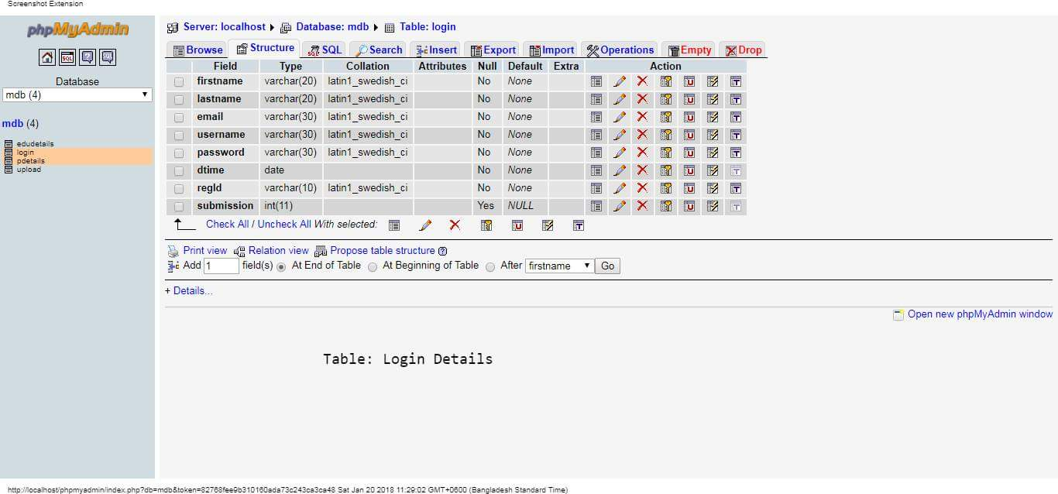

Table 4.6.1 Login Details

**4.6.2 Personal Details Table:**

All personal details of logged in students are stored into a table named by “Personal Details”.

The screen shot of the table is given below .

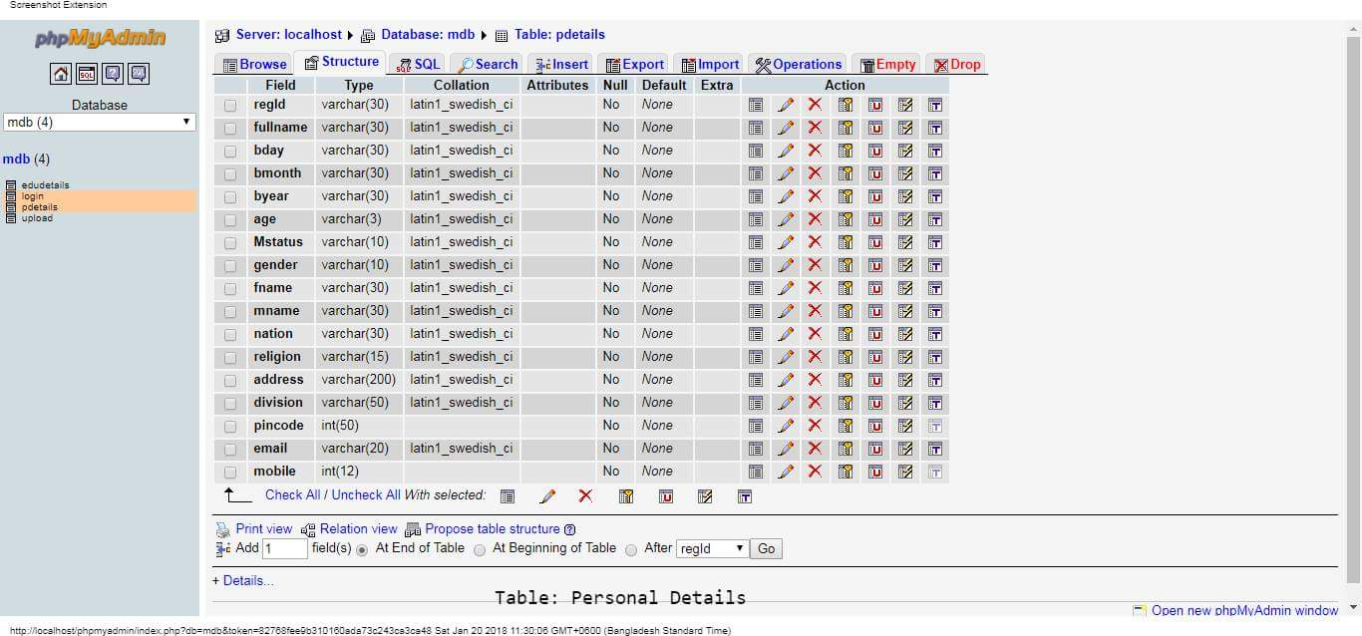

Table 4.6.2 Personal Details

**4.6.3 Educational Details Table:**

All educational details of logged in students are stored into a table named by “Educational Details”.

The screen shot of the table is given below .

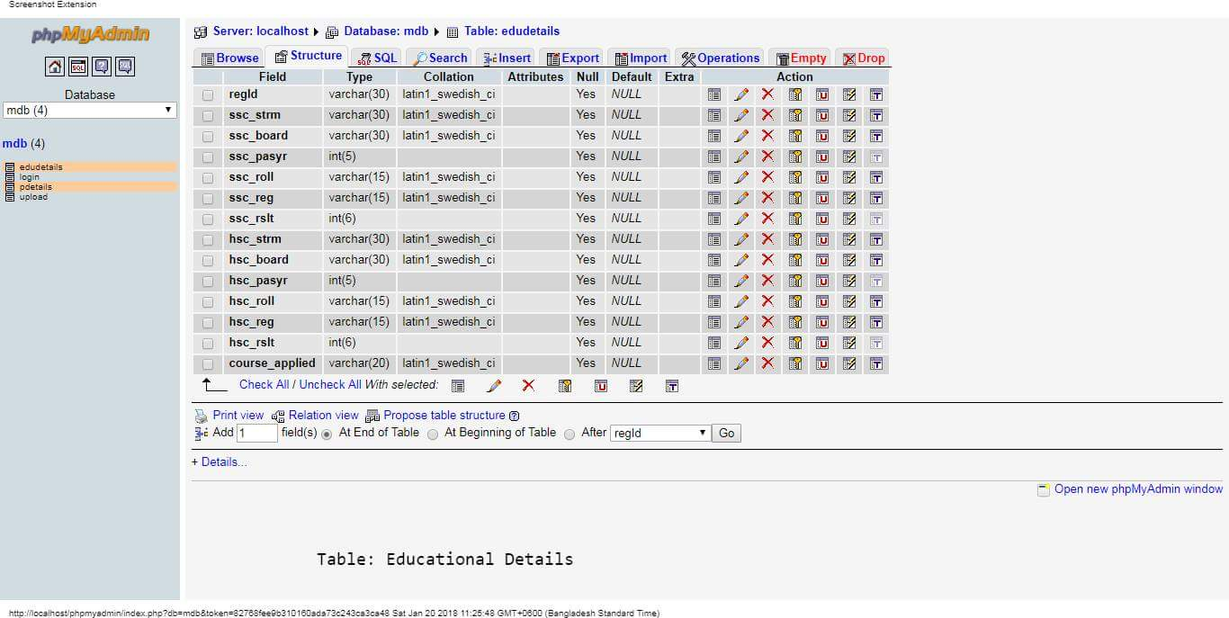

Table 4.6.3 Educational Details

**4.6.4 Upload Details Table:**

All upload files of registered students are stored into a table named by “Upload Details”.

The screen shot of the table is given below .

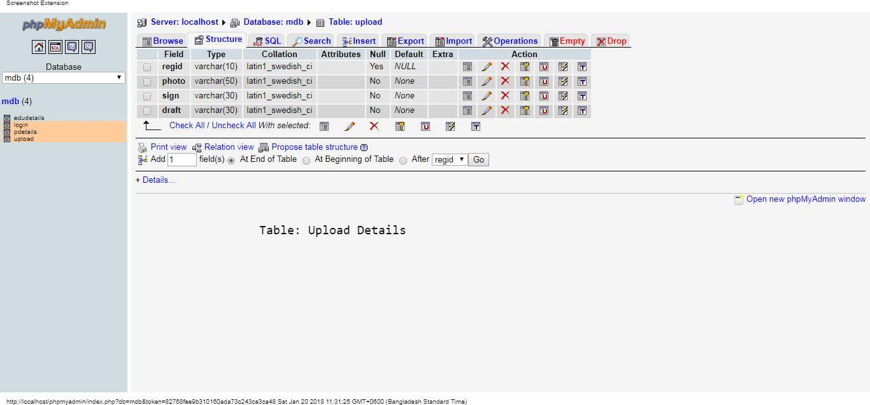

Table 4.6.4 Upload Details

***Chapter 5***

**SYSTEM DESIGN**

The system design develops the architectural detail required to build a system or product. As in the case of any systematic approach, this software too has undergone the best possible design phase fine tuning all efficiency, performance and accuracy levels.

**The first step,** in system designing is to determine how the output is to be produced and in what format. Samples of the output and input are also presented.

**In the second step**, input data and master files are to be designed to meet requirement of the proposed output. The processing phases are handled through program construction and testing, including a list of the programs needed to meet the system’s objectives and complete documentation.

**5.1 Design Methodology:**

System design is the solution to the creation of a new system. This phase is composed of several systems. This phase focuses on the detailed implementation of the feasible system. It emphasis is on translating design specifications to performance specification.

System design has three phases of development :-

1. Logical design.

2. Physical design.

3.Modular design.

**Logical Design :**

Logical design of an information system shows the major features and also how they are related to one another. The first step of the system design is to design logical design elements. This is the most creative and challenging phase and important too. Design of proposed system produces the details of the state how the system will meet the requirements identified during the system

analysis that is, in the design phase we have to find how to solve the difficulties faced by the existing system. The logical design of the proposed system should include the details that contain how the solutions can be implemented. It also specifies how the database is to be built for storing and retrieving data, what kind of reports are to be created and what are the inputs to be given to the system. The logical design includes input design, output design, and database design and physical design

**Physical Design :**

The process of developing the program software is referred to as physical design. We have to design the process by identifying reports and the other outputs the system will produce. Coding the program for each module with its logic is performed in this step. Proper software specification is also done in this step.

**Modular Design :**

A software system is always divided into several sub systems that makes it easier for the development. A software system that is structured into several subsystems makes it easy for the development and testing. The different subsystems are known as the modules and the process of dividing an entire system into subsystems is known as modularization or decomposition.

A system cannot be decomposed into several subsystems in any way. There must some logical barrier, which facilitates the separation of each module. The separation must be simple but yet must be effective so that the development is not affected.

The system under consideration has been divided into several modules taking in consideration the above-mentioned criteria. The different modules are :-

1. User module

2. Administrator module

**5.2 Input Design :**

The input design is the link between the information system and the user. It comprises the developing specification and procedures for data preparation and those steps are necessary to put transaction data into a usable form for processing data entry. The activity of putting data into the computer for processing can be achieved by inspecting the computer to read data from a written or printed document or it can occur by having people keying the data directly into the system.

The design of input focuses on controlling the amount of input required, controlling errors, avoiding delay, avoiding extra steps and keeping the process simple.

The system needs physical verification for various validation, checking, calculation and report generation. The error raising method is also included in the software, which helps to raise error message while wrong entry of input is done.

So in input design the following things are considered.

1. What data should be given as input?

2. How the data should be arranged or coded?

**5.3 Output Design :**

Computer output is the most important and direct information source to the user. Output design is a process that involves designing necessary outputs in the form of reports that should be given to the users according to the requirements. Efficient, intelligible output design should improve the system's relationship with the user and help in decision making. Since the reports are directing referred by the management for taking decisions and to draw conclusions they must be designed with almost care and the details in the reports must be simple, descriptive and clear to the user.

So while designing output the following things are to be considered.

1. Determine what information to present .
2. Arrange the presentation of information in an acceptable format.
3. Decide how to distribute the output to intended receipts .
4. Depending on the nature and future use of output required, they can be

displayed on the monitor for immediate need and for obtaining the hardcopy.

***Chapter 6***

**IMPLEMENTATION & TESTING**

The implementation phase is less creative than system design. It is preliminarily concerned with user training ,site preparation and file conversion .During the final testing use acceptance is tested .

**6.1 Home Page :**

This page is visible for all user ,it does not matter that if he/she is registered or not .In this page we define what type system it is and here we also provide feathers of our system .So from here user can get little knowledge about our system .



Fig 6.1 Home Page

**6.2 About us Page :**

In this page, user can know about admin and the system.

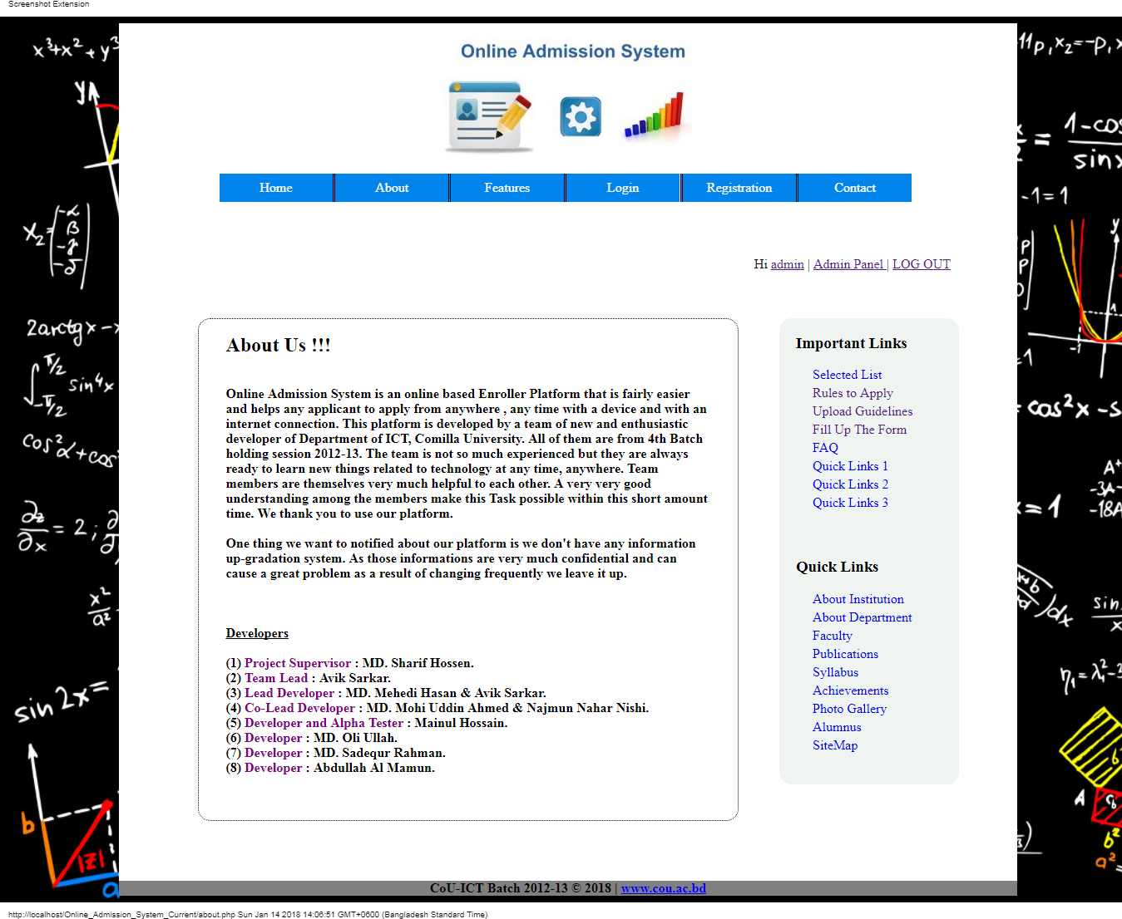

Fig 6.2 About us Page

**6.3 contact Us Page :**

To contact with the software developer of this system or give some massage to the developers.

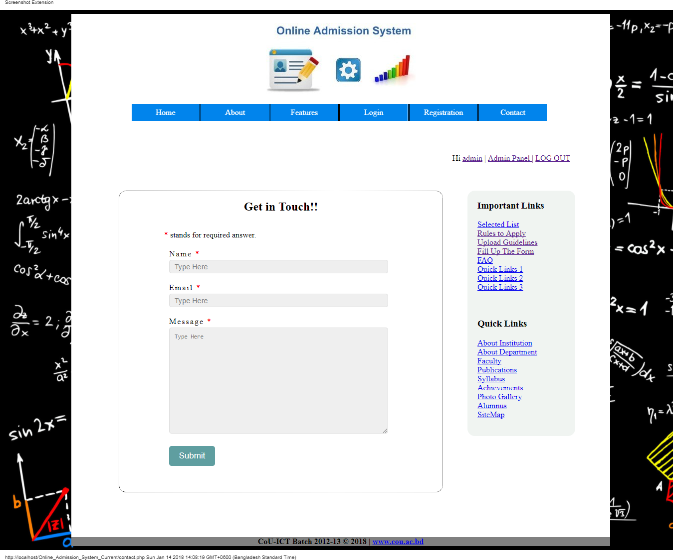

Fig 6.3 contact Us Page

**6.4 User Registration Page :**

User have to register himself at first to have the registration code .

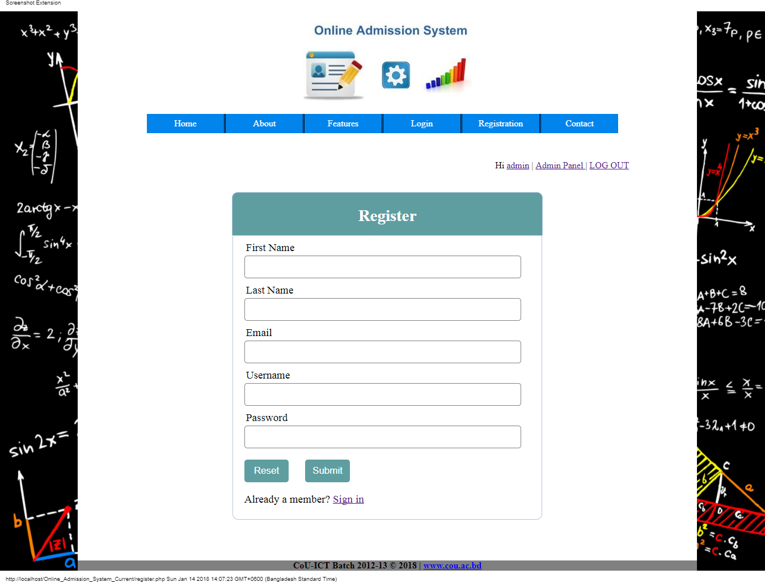

Fig 6.4 User Registration Page

**6.5 Login Page :**

This page is for both user and admin .All admin have a fixed username and password .Without login ,none can see the other pages.

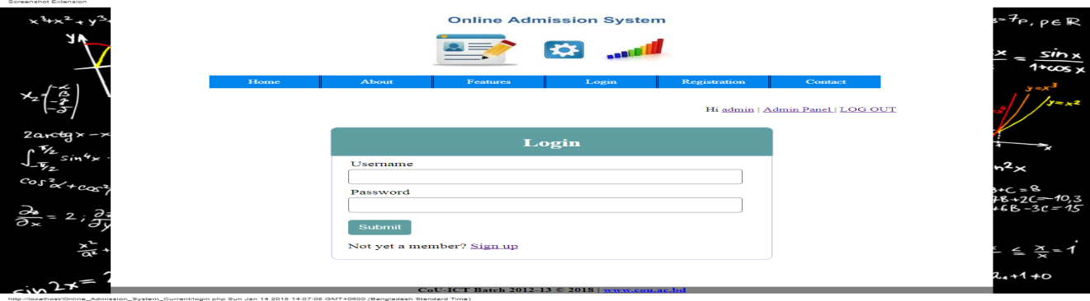

Fig 6.5 Login Page

**6.6 Submit Personal Details Page :**

Here all user must put all information that are wanted. User is allowed not to give non-required information.

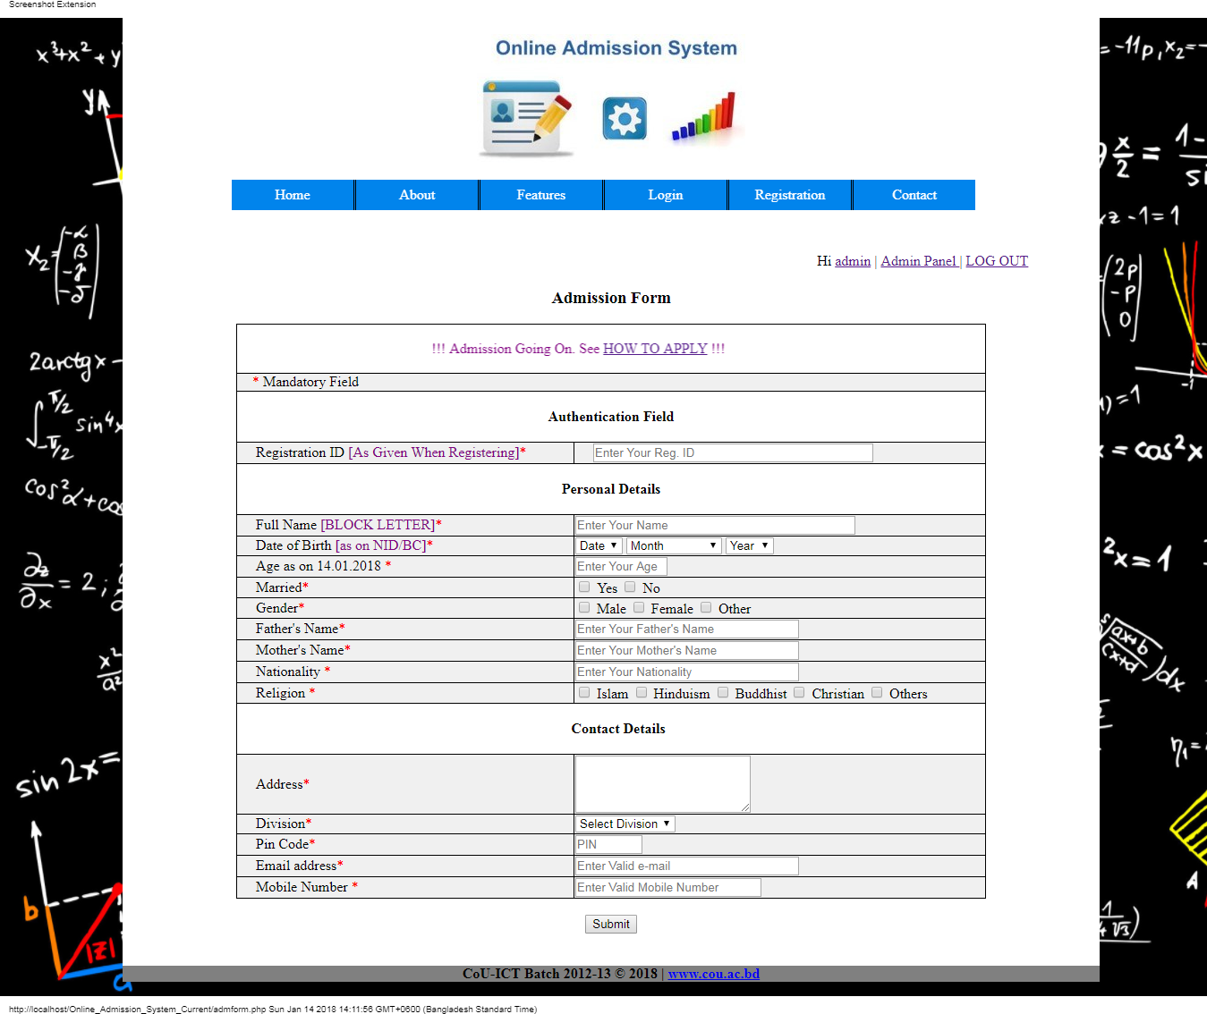

Fig 6.6 Submit Personal Details Page

**6.7 Submit Educational Details Page :**

To give educational details of the students.

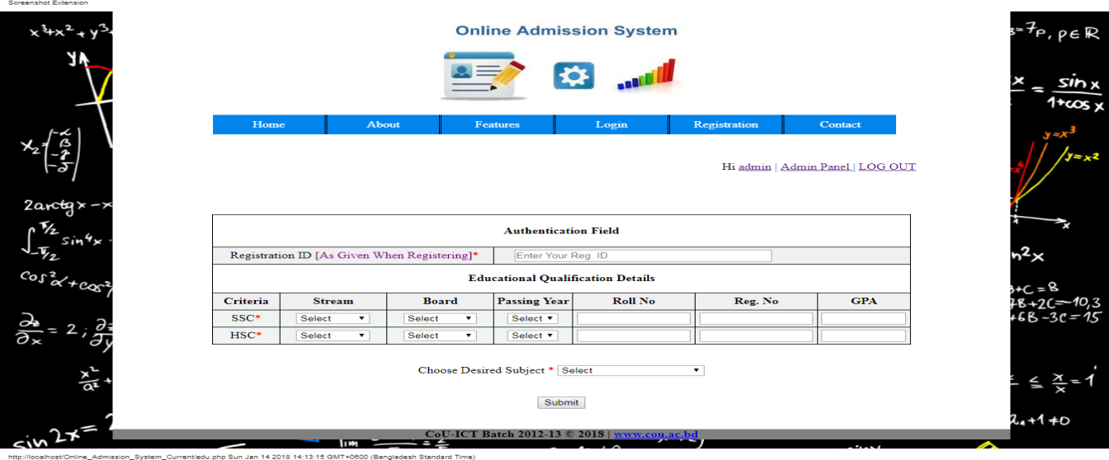

Fig 6.7 Submit Educational Details Page

**6.8 Submit Uploads Page :**

Students have to upload photo ,digital sign , scanned drafts .

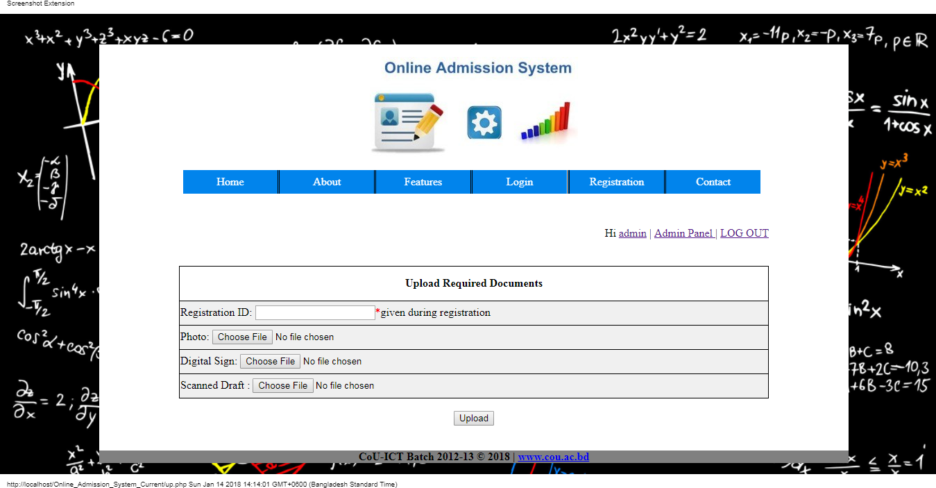

Fig 6.8 Submit Uploads Page

**6.9 Uploading Status Page :**

If anyone doesn’t upload necessary files or faces any problem when uploading, system gives him/her this status .

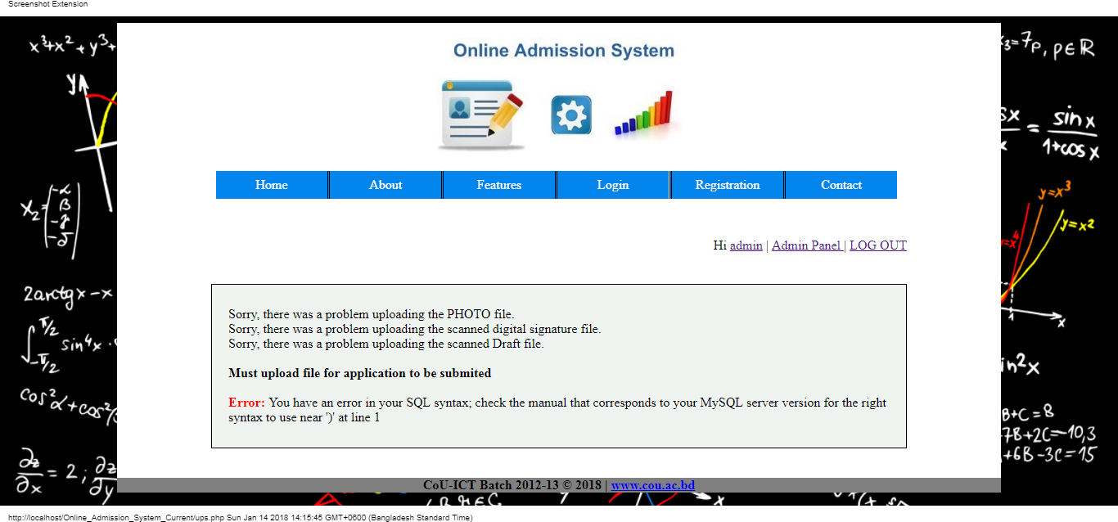

Fig 6.9 Uploading Status Page

**6. 10 Payment Page :**

User can complete payment by using VISA , PayPal ,Master Card , bKash ,Rocket ,Western Union .

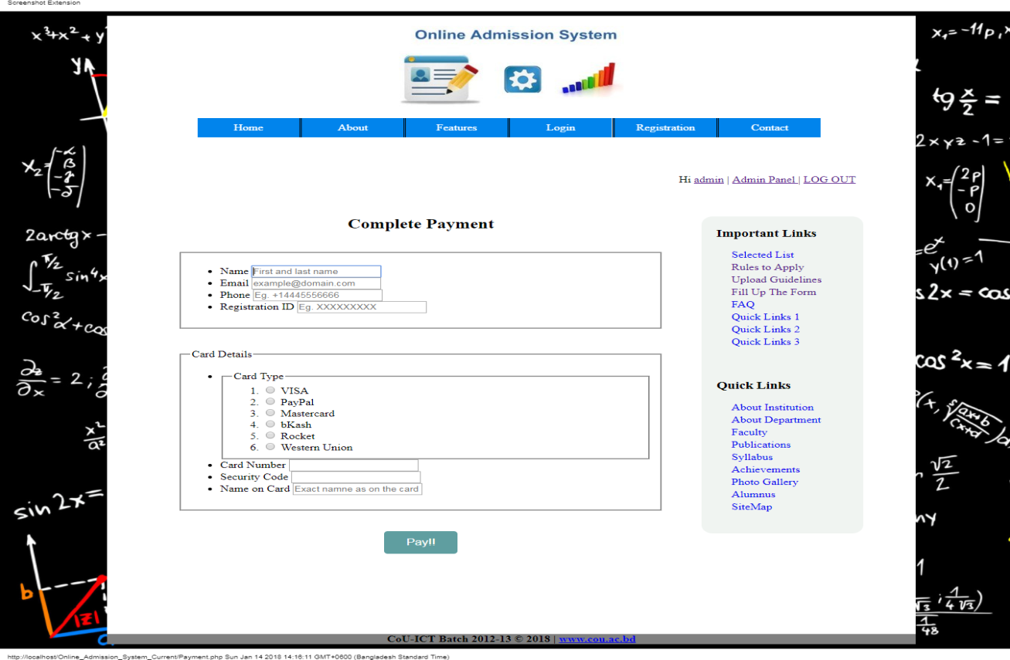

Fig 6. 10 Payment Page

**6.11 User List From Admin Panel Page :**

Admin can see all the list of registered students .

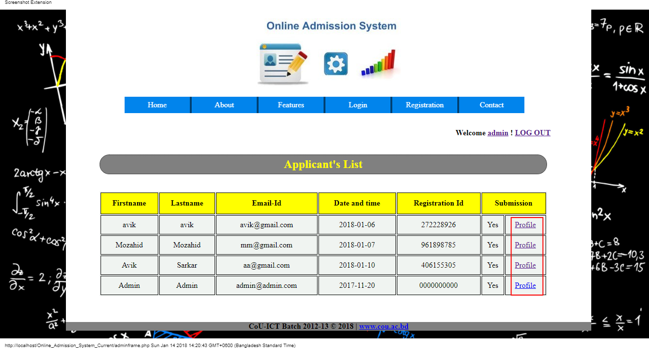

Fig 6.11 User List From Admin Panel Page

**6.12 User Profile Page :**

User can see his / her profile .Admin also can see students profile and he can delete unnecessary profiles using delete button .

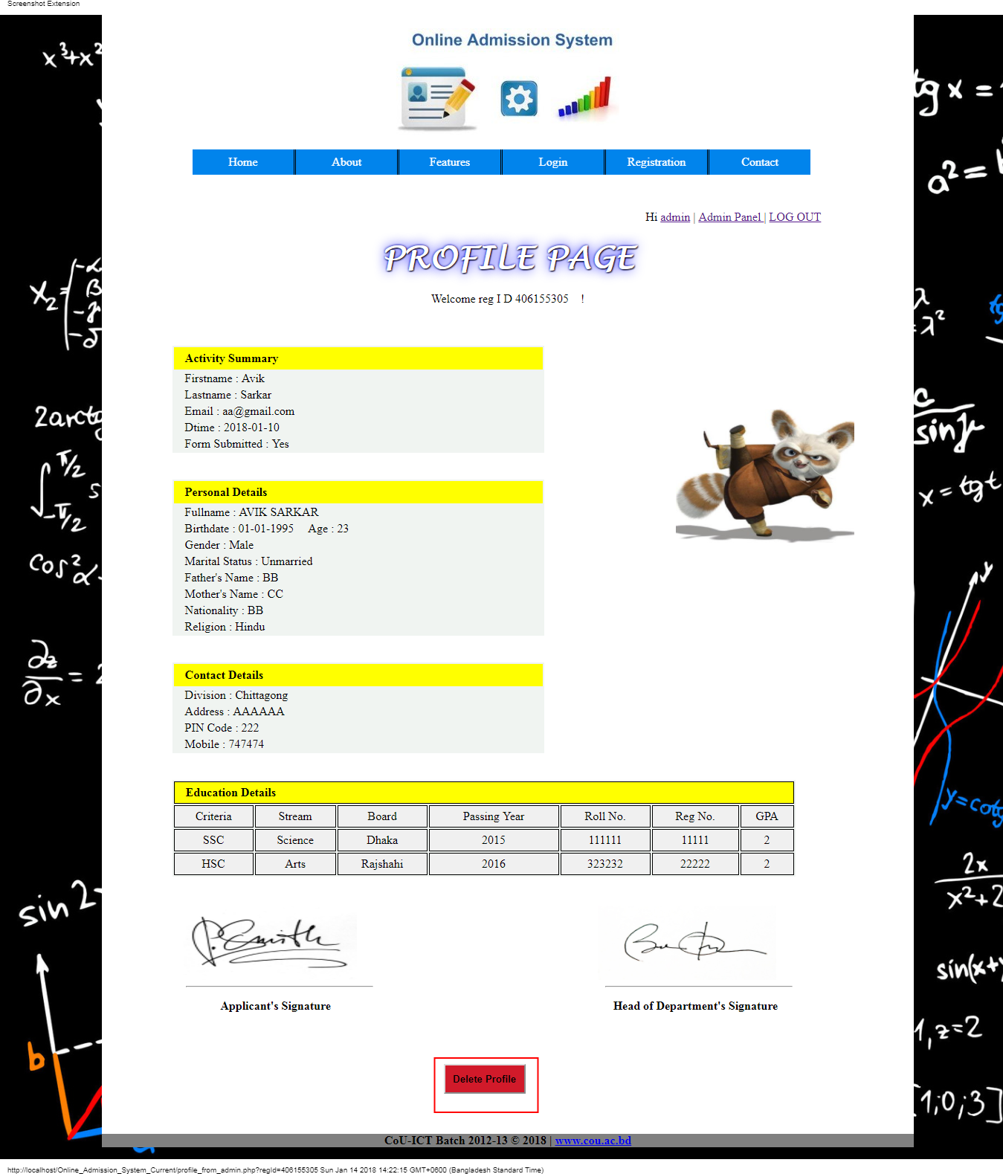

Fig 6.12 User Profile Page

**6.13 Admin Profile Page :**

This page contains admin details. Only admin can see this .

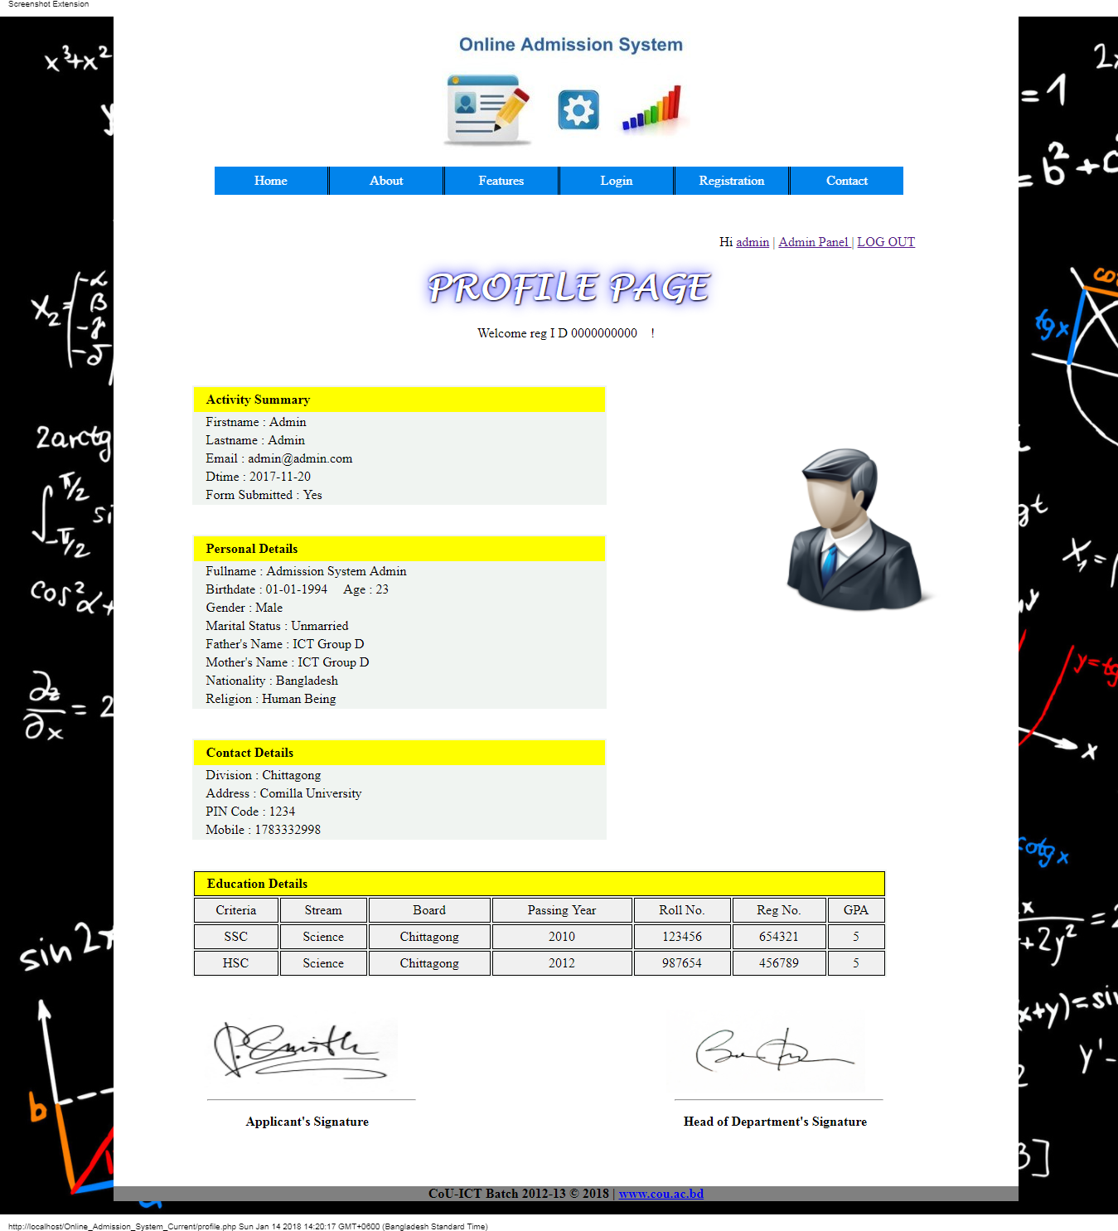

Fig 6.13 Admin Profile Page

**6.14 How To Apply Page :**

Students can know how to apply in this system from How To Apply Page .

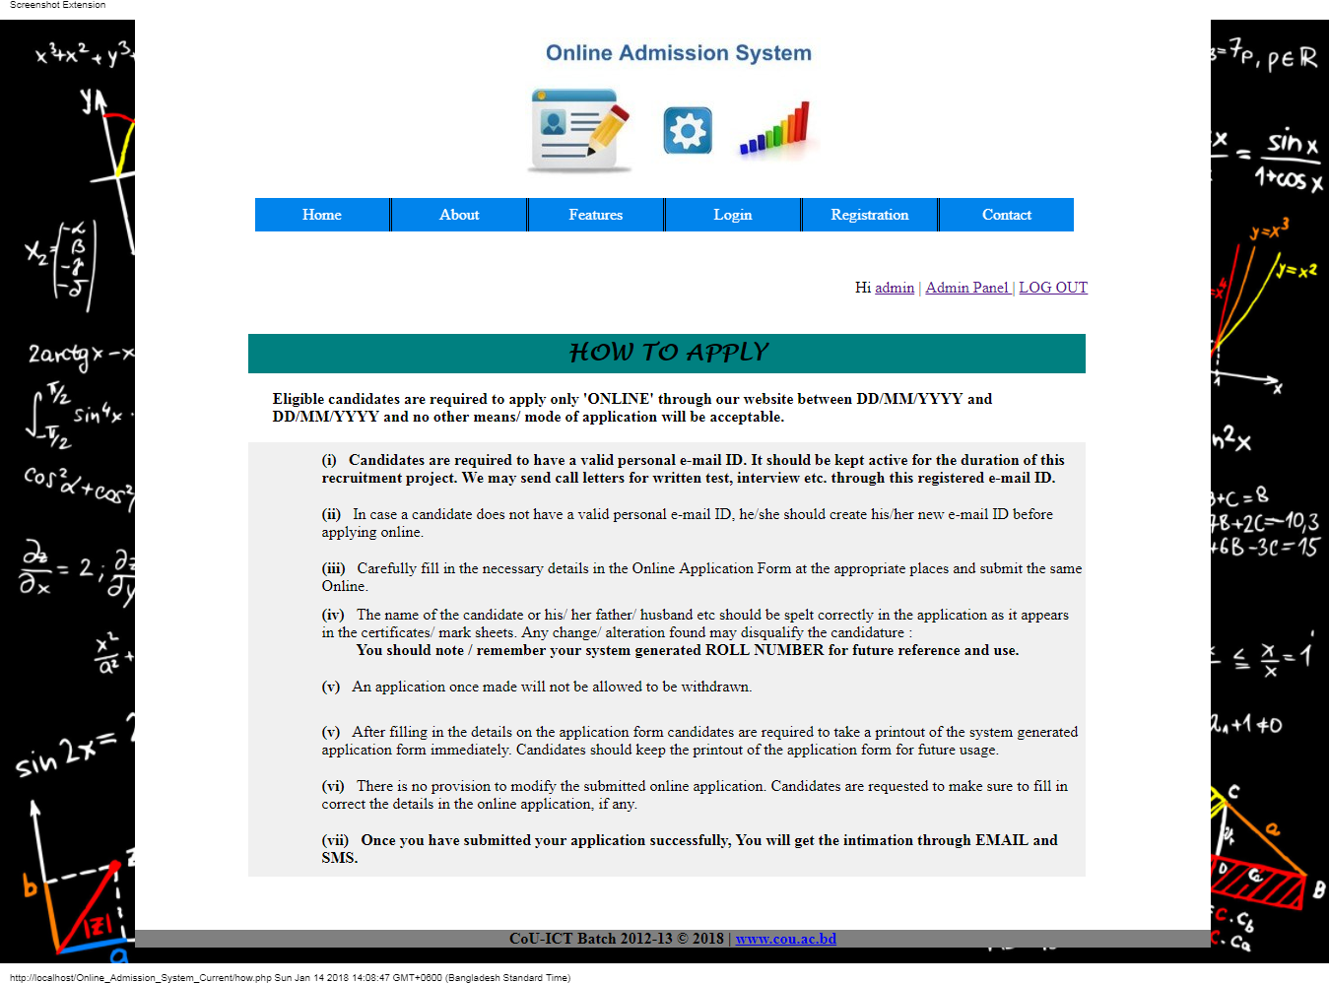

Fig 6.14 How To Apply Page

**6.15 Upload Guidelines Page :**

Students can get help from Upload Guidelines Page about uploading methods .

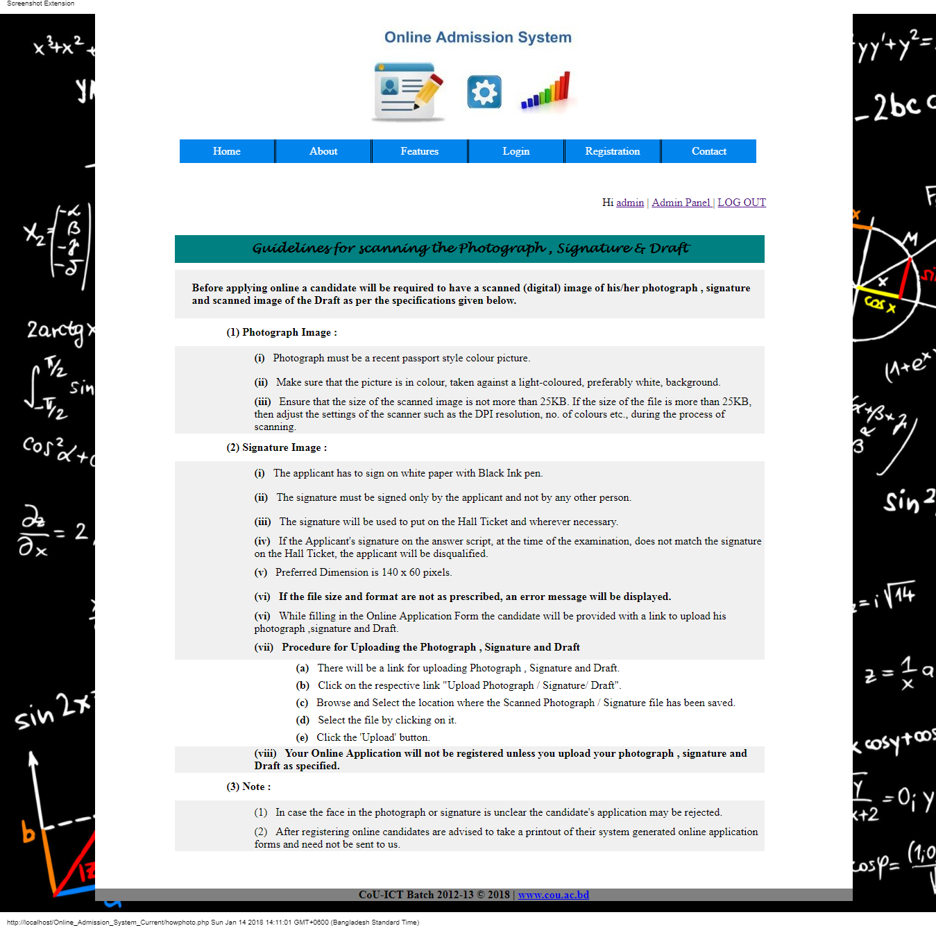

Fig 6.15 Upload Guidelines Page

**6.16 Testing :**

System testing is a critical aspect of software quality assurance and represents the ultimate review of specification , design and coding . testing is a process of executing a program with the intent of finding an error .a good test is one that has a probability of finding an as yet undiscovered error .The purpose of testing is to identify and correct bug in the developed system .Nothing is complete without testing .Testing is the vital to the success of the system .

**6.17 Optimization of Code :**

Code optimization aims at improving execution efficiency of a program. This is achieved in two ways:

* Redundancies in a program are eliminated.
* Computations in a program are rearranged or rewritten to make it execute efficiently.
* The optimization must not change the meaning of a program.

**6.18 Validation Checks :**

Validation means observing the behavior of the system. The verification and validation means that will ensure that the output of a phase is consistent with its input and that the output of the phase is consistent with the overall requirements of the system. This is done to ensure that it is consistent

with the required output. If not we apply certain mechanisms for repairing and thereby achieved the requirement.

**6.19 System Security Measures:**

Any system developed should be secured and protected against possible hazards. Security measures are provided to prevent unauthorized access of the database at various levels. An uninterrupted power supply should be so that the power failure or voltage fluctuations will not erase the data in the files.

**6.19.1 Technical Security Measures:**

This is associated with technical problems such as exception conditions detected during execution. This exception should be programmed in the system itself. System errors are some operation during the execution may cause it to fail. This is because of logical programming error. So it is essential to handle these problems effectively.

**6.19.2 Infrastructure Security Measures:**

This is associated with computer failure, system crash, and disk failure. Physical problems and catastrophes refers to an endless list of problems that includes power air conditioning failure, fire, theft, damage, overwriting disk or tape by mistake.

**6.19.3 Organizational Security Measures:**

Some problems occur in organization due to the concurrent execution of system. Prevention of labor turnover is another security measure related to the organization.

**6.19.4 Personal Related Security Measures:**

This security is concerned with offering security to the persons who are developing and using the system. This is offered by providing username and password for each and every person using the system.

***Chapter 7***

**FUTURE SCOPE & CONCLUSION**

**7.1 Future Scope :**

The future scope of this project is very broad

Few of them are:

* 1. This can be implemented in less time for proper admission process.
  2. This can be accessed anytime anywhere, since it is a web application provided only an internet connection.
  3. The user had not need to travel a long distance for the admission and his/her time is also saved as a result of this automated system.

**7.2 Conclusion :**

In the conclusion of this report ,the following aspects are discussed :

*Chapter 1 :* The project is briefly introduced .

*Chapter 2 :* In this section ,the background of the project is described .

*Chapter 3*: The requirements are analyzed.

*Chapter 4:* System analysis are discussed in this section .

*Chapter 5 :* The design of the system are discussed .

*Chapter 6 :* The system are tested and evaluated .

This system, being the first we have created in PHP, has proven more difficult than originally imagined. While it may sound simple to fill out a few forms and process the information, much more is involved in the selection of applicants than this. Every time progress was made and features were added, ideas for additional features or methods to improve the usability of the system made they apparent. Furthermore, adding one feature meant that another required feature was now

possible and balancing completing these required features with the ideas for improvement as well as remembering everything that had to be done was a project in itself. Debugging can sometimes be a relatively straight forward process, or rather finding out what you must debug can be. Since so many parts of the admissions system are integrated into one another, if an error occurs on one page, it may be a display error, for example; it may be the information is not correctly read from the database; or even that the information is not correctly stored in the database initially, and all three must be checked on each occasion. This slows down the process and can be frustrating if the apparent cause of a problem is not obvious at first. Language used must be simple and easy to understand and compatibility is paramount. If this system were not designed as an entirely web based application, it would not have been possible to recreate its current state of portability.

Overall, the system performs well, and while it does not include all of the features that may have been desired, it lives up to initial expectations. The majority of features that are included work flawlessly and the errors that do exist are minor or graphical.

After doing this project, we have learned many things and we would like to thank all the concerned individuals who have contributed to our precious learning .We have also understood the importance of naming convention and coding conventions in development process.

A efficient Online Admission System website requires the following characteristics which this system already has. These are :

|  |  |  |
| --- | --- | --- |
| Accuracy | Reliability | Flexibility |
| Democracy | Verifiability | Privacy |
| Mobility | Social acceptance | Consistency |

**Bibliography**

- The PHP Manual-www.php.net.

- PHP Manual-www.w3school.com.

- PHP Manual-www.9lessons.info.

- Wikipedia

- A press Beginning PHP 5 and MySQL 5 From Novice to Professional 2nd Edition.pdf

- Stack overflow site.

- tutorialspoint.com

- HTML Tutorials and Practices – w3schools.com

- JS Tutorials and Practices – w3schools.com

- youtube.com PHP and MySQL Playlist.